|  |  |  |
| --- | --- | --- |
| **Problem Chosen A** | **2020 MCM/ICM**  **Summary Sheet** | **Team Control Number 0000012** |

# Oil Forecast in Different Aspects

Abstract

Since the advent of the internal combustion engine, oil has undeniably become one of the most important energy sources for human society. It is precisely because of this that the topic of oil can always arouse heated discussions in the international arena. The influence of oil goes beyond the energy field and even the economic field. Starting from the production and consumption of oil, this article predicts **the future use of oil**, and puts forward our recommendations on energy on this basis.

In Part I, our research will start from the perspective of production. Based on the production data of PetroChina over the past century, we first **improved the Hubbert Curve**. Then use the improved Hubbert Curve to predict the time of peak oil and oil depletion, with probable policy restrictions and technological progress taken into consideration. The results show that oil will lose its value as a commodity around 2085. This data may change due to policy changes and technological breakthroughs.

In Part II, from **the perspective of oil consumption**, we focus on various alternatives to oil, and use data fitting methods to predict oil consumption trends.

In part III, we consulted a large number of economics literature, and finally based on the existing prediction results, combined with the cost of goods, supply and demand and the characteristics of the **commodity market**, we gave our oil price function model, and used the past oil price Data detection and improvement of the model, and finally used the model to predict the future oil price. The results show that: In the long run, oil will remain at a relatively stable level, the trend of oil price fluctuations will become slower, and fluctuations will gradually become more rational.

In Part IV, we studied the relationship between the country's economic development level and GDP's dependence on energy, and divided the country into three categories based on the results, and put forward recommendations on **boosting the economy**, **protecting the environment**, and **maintaining energy security**. Naturally, the work of protecting the environment and maintaining energy security cannot be completed by one country. Therefore, in Part V, we also put **forward suggestions** to the United Nations on helping backward countries.

Keyword: **Hubbert Curve Oil Depletion Smart Energy Arrangement**

### Contents

1. Introduction ------------------------------------------------------------------------------- 2
   1. Background
   2. Problem Restatement
2. Assumptions and Justification ---------------------------------------------------------- 2
3. Notations ---------------------------------------------------------------------------------- 3
4. Oil Depletion Model --------------------------------------------------------------------- 3

4.1 Problem Analysis

4.2 Model Design

4.3 Improvement of Hubbert model

4.4 Quantitative analysis of the upcoming peak oil

5. Oil Consumption-------------------------------------------------------------------------- 7

5.1 Problem Analysis

5.2 Model Construction

5.3 Model Solution

6. Smart Energy Plan -------------------------------------------------------------------- 10

6.1 Countries in the Early Stage of Industrialization

6.2 Countries in the Middle of Industrialization

6.3 Developed Countries

7. Oil Price Forecast Model ------------------------------------------------------------- 13

7.1 Problem Analysis

7.2 Model Construction

7.3 Model Solution

8. Model Analysis -------------------------------------------------------------------------- 16

8.1 Advantages

8.2 Disadvantages

8.3 Sensitivity

9. A one-page letter to the UN ------------------------------------------------------------ 18

Reference ------------------------------------------------------------------------------------ 19

Appendix ------------------------------------------------------------------------------------ 20

### 1. introduction

#### Background

Since the Industrial Revolution, human social and economic development has begun to enter the fast lane. The economic development of modern society is basically based on the dependence on **fossil energy** (oil, coal, natural gas, etc). Through the advancement of science and technology, people have explored more and more fossil energy.

Some people are **optimistic** that there are enough fossil energy sources on the earth to transition directly from the oil and gas era to the atomic energy era, so we do not need to worry about energy issues. But there are also many people who oppose this, who think oil will be exhausted in 57 years, not to mention the rate of oil consumption is accelerating.

Will the depletion of oil come? Will we face an impending energy crisis? Human beings’ high dependence on oil will bring us peace and prosperity, or crisis? Facing the energy crisis, what can we do? In response to the above problems, we launched this study.

#### 1.2 Restatement

**Part I:** Using historical data to establish a model to forecast the exhausted oil commodity .

**Part II**: Establishing a mathematical model to forecast the trends and peak of oil consumption.

**Part III**: Using some factors and the result of **Part I** and **Part II** to forecast the oil price.

**Part IV**: Providing a concrete smart energy plan for the future, which includes many factors that is useful in our eyes.

**Part V:** Write a one-page letter to the UN to explain the specific plan and how to carry it out.

### 2. Assumption and Justification

* In the future, the world economy will develop steadily without major wars or plagues. People's demand for resources will increase in a controlled manner as in the past few decades.
* In the case of the same production process, the oil well production is roughly in line with Hubbert curve.[3]
* There is still controversy in the academic circles about the production of oil, and we adopt the theory of bio-oil formation: we agree that oil, like coal and natural gas, is gradually formed by ancient organic matter through long compression and heating. According to the calculation of surface organic matter, humans have discovered most of the oil on the earth. This means that it will be more and more difficult for us to find new crystals, especially high power.
* This means that mankind can no longer use technologies other than conventional methods to extract commercially valuable alternatives.
* All economic indicators have all been converted according to the current currency rate. It is assumed that future prices are not affected by the currency rate and are equivalent to the current currency.

### 3. Notations

|  |  |
| --- | --- |
| symbol | Definition |
| P | the crude oil production per unit time |
|  | the peak time |
|  | function parameters |
|  | the oil price generated by oil reserves and consumption |
|  | the oil price generated by policy and living environment |
|  | subsequent independent small production peaks due to technological improvements and the discovery of new oil fields. |
|  | the oil price generated by economic factors |
|  | total oil price |
|  | the set containing all improved Hubbert Curves satisfying the condition |
|  | the absolute value of the difference between oil reserves and oil consumption |
| , | used to measure climate, war, and policy respectively |
|  | GDP per capita |

### Oil Depletion Model

#### 4.1 Problem Analysis

Although oil is a vital nonrenewable or exhaustible resource, it is buried deep underground, and human beings do not have the ability to completely drain the oil on the earth. Therefore, our definition of oil depletion is the moment when oil loses its value as a commodity. We have to find this moment first.

For oil production, we will be based on the Hubbert Curve theory, which has been proved effective. However, the Hubbert Curve did not consider changes in technology and policies, so we must first adjust the Hubbert Curve model. The adjusted the Hubbert Curve is used to fit the two peak oil peaks that occurred in the last century, and then the third peak oil peak that will appear this century due to the introduction of A technology is isolated for subsequent analysis.

Finally, use the above data to predict the depletion of oil.

#### 4.2 Model Design

**The signs of oil depletion**:

Although oil is a non-renewable resource, it is widely used in all walks of life due to its cheapness. We investigated a large amount of data, and finally based on the data on the ratio of oil consumption by various industries in the world, we set the year when oil production was 2% of oil production in 2019 as a sign of oil depletion. When **only 2% of petroleum petroleum** can not meet the requirements of transportation functions and heating, and can only be used to produce plastics and special industrial consumables, petroleum at this time must not be used as a commodity to circulate and trade around the world. Therefore, this mark is reasonable.

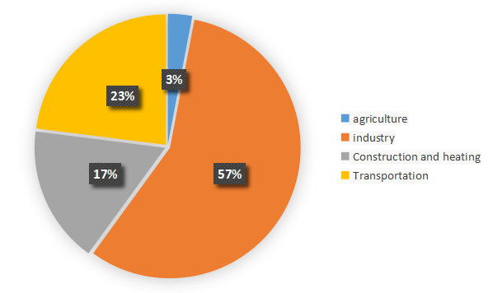

Figure1: the ratio of oil consumption by four main industries

#### 4.3 Improvement of Hubbert model

The Hubbert curve is an approximation of the production rate of a resource over time.It first appeared in "Nuclear Energy and the Fossil Fuels," geologist [M. King Hubbert](https://en.wikipedia.org/wiki/M._King_Hubbert" \o "M. King Hubbert)'s 1956 presentation to the [American Petroleum Institute](https://en.wikipedia.org/wiki/American_Petroleum_Institute" \o "American Petroleum Institute), as an idealized symmetric curve, during his tenure at the [Shell Oil Company](https://en.wikipedia.org/wiki/Shell_Oil_Company" \o "Shell Oil Company).[3] It has gained a high degree of popularity in the scientific community for predicting the depletion of various natural resources. The curve is the main component of [Hubbert peak theory](https://en.wikipedia.org/wiki/Hubbert_peak_theory" \o "Hubbert peak theory), which has led to the rise of [peak oil](https://en.wikipedia.org/wiki/Peak_oil" \o "Peak oil) concerns. Basing his calculations on the peak of oil well discovery in 1948, Hubbert used his model in 1956 to create a curve which predicted that oil production in the contiguous United States would peak around 1970.The Hubbert curve of a single oil field is as follows:

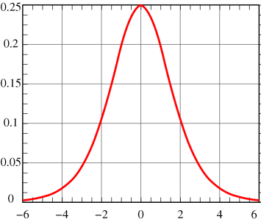

Figure2 : the original Hubbert Curves

 (1)

In which P represents the crude oil production per unit time, represents the peak time, are function parameters.

But when we look back on history, we can find that although the world oil production did reach a peak around 1970, the world oil production after 1970 was not as predicted by the curve. There are three main reasons:

**Policy changes**: Governments of various countries have begun to lift restrictions on oil production and import and export, which has increased the production enthusiasm of oil companies;

**Exploring technological innovation**: Hydraulic fracturing (fracking) or acidizing may be used to cause a sharp spike in production, and may increase the recoverable reserves of a given well；

**Discovery of new oil fields**: Hubbert model is only applicable to a single oil field. As the demand for oil increased, explorers became obsessed with discovering new oil fields to generate income.

By further reading the literature[4], we learned that, A secondary recovery project, such as [water](https://en.wikipedia.org/wiki/Water_injection_(oil_production)" \o "Water injection (oil production)) or gas injection for a old oil well or the discovering of a new oil field can bring independent Hubbert Curve. Therefore, with the help of two documents[5],[6], we have improved the model:

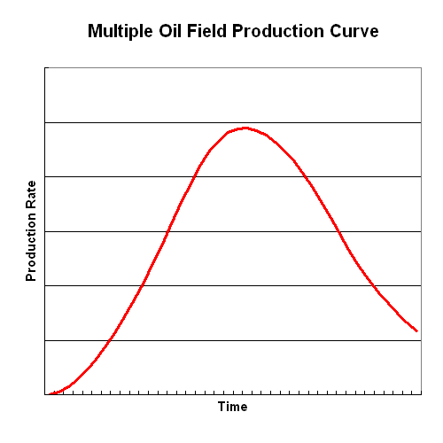

Figure3 : improved Hubbert Curves

 (2)

In which represents the first oil peak in 1970, and represents the second peak of oil after the supergiant Prudhoe Bay field in Alaska was put into production, represents subsequent independent small production peaks due to technological improvements and the discovery of new oil fields.(In the appendix we provide a detailed generation process.)

Figure 4: the fix of the improved curve

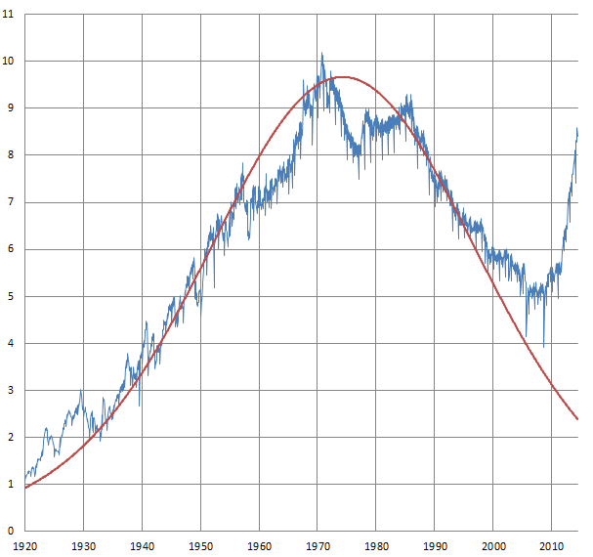

In this way, we have established a quantitative relationship between **the ideal Hubbert curve** and **the real oil well production**.

Using the improved curve, we can better fit the oil production of all known peak times.

**4.4 Quantitative analysis of the upcoming peak oil**

With the Hubbert Curve of the first peak oil and the data of crude oil production since this century, we can separate the Hubbert Curve of the new peak oil through analysis to facilitate subsequent forecasts. In the Hubbert Curve of the new new peak oil, the annual crude oil production rate is:

 (3)

In which the represents the observed value of oil production after 1980.

Since we have established a quantitative relationship between the **ideal Hubbert curve** and the real oil well production, the next step is to determine the new peak oil Hubbert curve. We use the progressive difference method to find the rate of change of oil production efficiency between 2000 and 2019, and the parameters solved by the simultaneous equations:

 (4)

In fact, for the sample of crude oil production rates since this century, for any functions like:

 (5)

If it satisfies **the likelihood ratio of the sample**，in which is a given quantity, then the assumption that "A is a regression function of oil production rate" can be accepted. We take "the set containing all functions  satisfying the condition" as set .Since we have no way of knowing the number and scale of potential, undiscovered oil fields, and the future innovation of crude oil mining technology, for each Hubbert function in , there will be several improved Hubbert Curves that match it. If we take "the set containing all improved Hubbert Curves satisfying the condition" as set Then we can find the most optimistic function and the most pessimistic function for future output from , as shown in the figure:

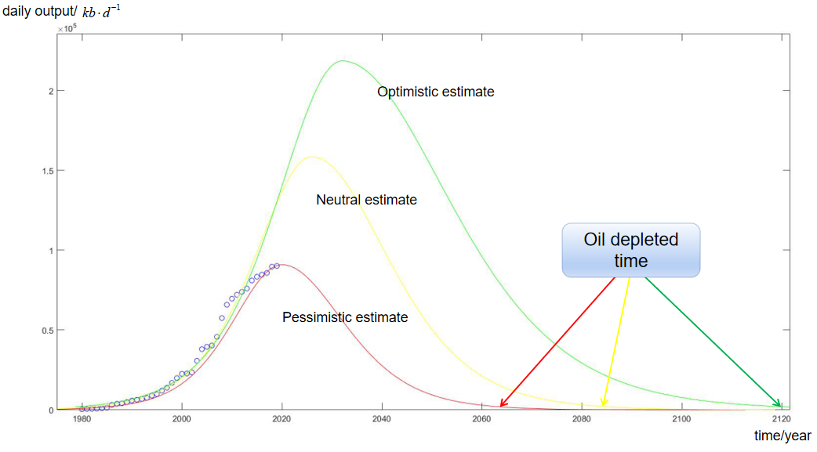

Figure 5: Different predictions for oil depletion time

According to our calculations, the depletion of oil is likely to come around 2085, the earliest may be 2064, and the latest may be 2120.

### 5. **Oil Consumption**

#### 5.1 Problem Analysis

Generally speaking, because the cost of oil storage is relatively high relative to the cost of production, the oil consumption curve and oil production curve are consistent in most cases. But from a dialectical point of view, consumption also has a counterproductive effect on production, so Part II will focus on the future world demand for oil.

One of the greatest global challenges is to integrate environmental sustainability with economic growth and welfare by decoupling environmental degradation from economic growth and doing more with less. Resource decoupling and impact decoupling are needed to promote sustainable consumption and production patterns and to make the transition towards a greener and more socially inclusive global economy.[9]

Figure6: National crude oil reserves

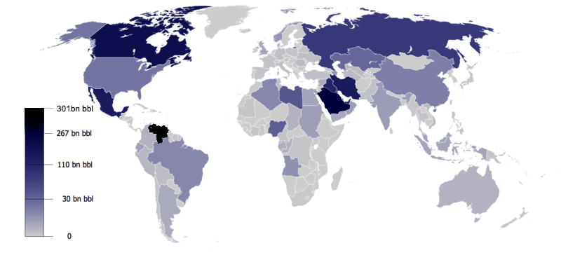

One fact is: the distribution of oil in the world is uneven. The latest research shows that new synthetic dyes such as dimethyl ether and methanol can also be a good substitute for petroleum. From the perspective of oil substitutes, we consider the changing trend of oil consumption.

#### 5.2 Model Construction

We should first determine the total amount of energy required by humans. We have obtained data on world population, per capita energy consumption and world total energy consumption. First, fit the curve of world population and per capita energy consumption:

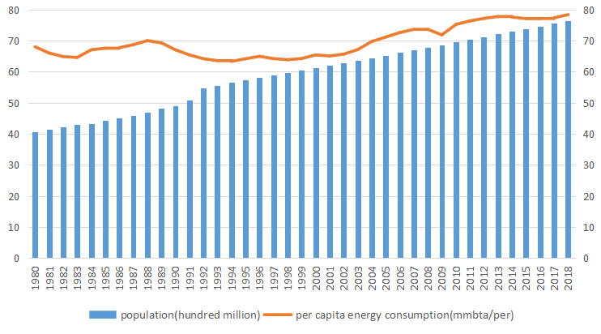

Figure7: Forecast of world population and energy consumption per capita

It can be found that the two values are both linear. Using the fitting results, we have predicted the world total energy consumption. It can be found that for the past data[10], the predicted results are in good agreement with the actual situation.

Figure8: The world's total energy consumption data and our forecast

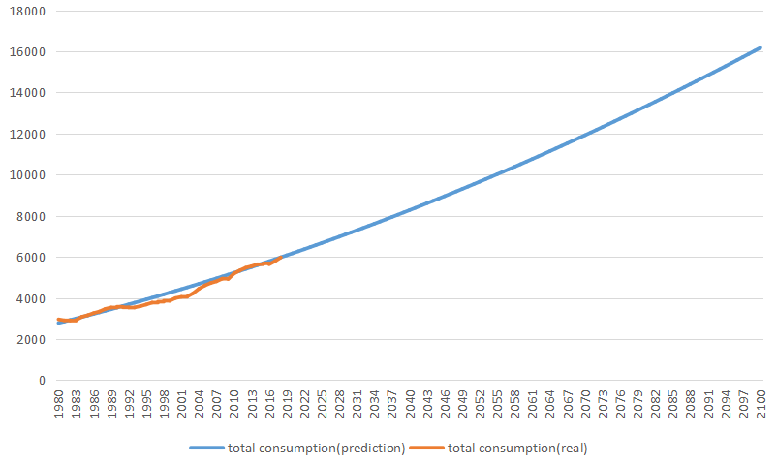

**5.3 Model Solution**

In the end, our predictions for energy supply from various resources are as follows:

Figure9: Forecast of various energy consumption

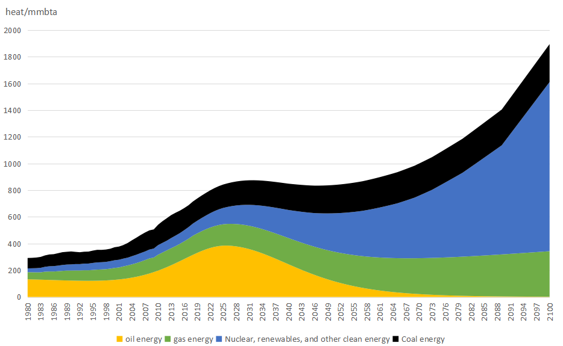

It can be found that due to technical limitations[11], nuclear energy and biomass energy cannot be promoted on a large scale in the past 10 years. Therefore, oil must be used to provide energy to meet the increasing needs of human society, and oil consumption will also reach its peak; With the advancement of synthetic fuel technology, more coal mines on the earth have been put into use, alleviating the crisis of oil depletion. In addition, more clean energy will also be developed (such as combustible ice), and oil will gradually decline with the increase in oil production costs, and finally be launched on the market.

### 6. Price Forecast Model

#### 6.1 Problem Analysis

The questions are divided into two levels. (1) Look for historical oil price data and consider important indicators other than the first and second questions that affect the oil price trend; (2) Make a function based on the given indicators to formulate forecast oil prices Trending model. For the selection of indicators, we combined the data analysis of one or two questions and the data query of reference documents to determine the indicators of oil consumption, oil reserves, policies, living environment, and economy (not enough); for indicator processing, We first obtain a large amount of effective data through literature data, and use mathematical methods to link indicators to oil prices, establish parameters through the relationship between indicators and oil prices, establish a reasonable oil price prediction model, and finally bring actual oil price data to test the oil price forecast trend The rationality of the model.

#### 6.2 Model Construction

According to our ideas, the oil price trend prediction model is affected by a variety of indicator factors, so we need to analyze the indicators one by one, and the year-on-year data of oil prices is a reflection of the influence of various indicators. Therefore, through the analysis of each data volume of oil price, we can use the mathematical undetermined coefficient method to find the quantification of each parameter index.

**Oil consumption and reserve indicators**: According to the literature[1], because the absolute difference between oil reserves and consumption is directly linked to the impact of oil prices, and the actual values of the two can be displayed intuitively, we can directly use the oil reserves and consumption The specific actual value of the quantity is used to list the expression of its influence on the oil price, which is calculated from the literature data:

 (6)

 represents the oil price generated by oil reserves and consumption,  represents the absolute value of the difference between oil reserves and oil consumption,  represents volatility, and the confidence interval for the degree of volatility is 95%.

**Policy and living environment indicators**: Through literature data[2], we found that the model mainly considers the climate environment of the people and the outbreak of wars of different scales in the major origins of oil worldwide

 (7)

 represents the oil price generated by policy and living environment, and, is used to measure climate, war, and policy respectively. We simplify the model. The three variables are uniformly discrete, and the variable 01 is used instead. 0 means that there is no climate, policy, or war in the year The factors that have a serious impact on people’s lives, on the contrary, 1 means existence;

**Economic indicators**: The indicator is measured by reference to the economic level of people’s growth, taking into account the global economic level, so it is measured by the global annual per capita GDP, and the relationship between the per capita GDP value and the parameter is directly used to express the indicator’s impact The influence of oil price is calculated as[7]:

 (8)

 represents the oil price generated by economic factors, and  represents GDP per capita

**Singularity analysis**:

The singularity of oil prices symbolizes a process of drastic changes in oil prices, that is, the essential transition of the price level, resulting in significant differences. Based on the analysis of historical oil price data, we accurately find the singularity of oil prices and accurately correspond to them. The three oil crises have also fully demonstrated that sudden time will have structural changes to oil prices. Because these three huge oil crises are difficult for us to fit in the function and incorporate them into policy and living environment indicators, we will analyze them separately here[7].

|  |  |  |
| --- | --- | --- |
| Time | Changing mean value($) | Standard deviation of oil price ($ ) |
| 1981.3-1985.12 | 12.91 | 3.56 |
| 1986.3-1989.11 | 14.92 | 2.40 |
| 1991.12-2005.2 | 5.17 | 6.96 |

Figure10 : Different standard of oil price in different times

Therefore, we can use the standard price to process the historical oil price data in advance, and then perform the fitting process on the oil price function to draw more accurate conclusions.

#### 6.2 Model Solution

The factor indicators established in the model are all economic factors, so we add up all the indicators to derive the oil price function model

 (9)

In which  represent total oil price.

Through the solved oil price model model, bring in data, calculate the oil price over the years, and refer to the oil value obtained after currency conversion.

Figure11: the comparison of actual and calculated value

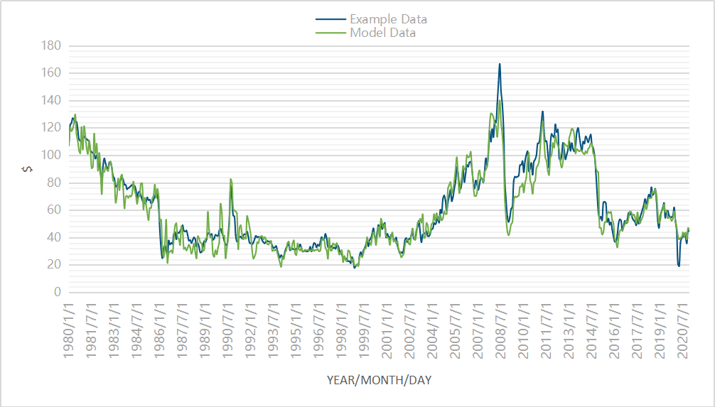

Through image comparison, we found that the function model obtained through historical data and the parameter value of the quantified influence factors in the literature reference basically matches the past oil prices. Therefore, we can conclude that our oil price model is basically in line with the development trend and can be derived from this model. The short-term future trend of oil prices.

Figure12: the oil price in short-term future

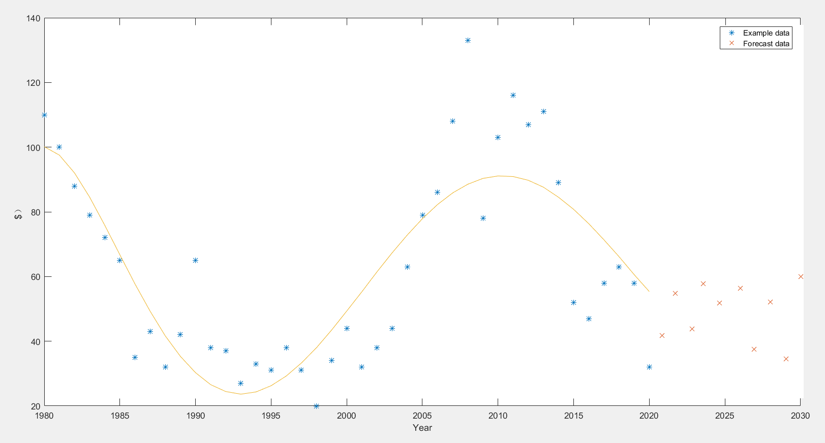

**Long-term forecast of oil prices**[8]

The resource characteristics of oil determine its price instability factors. In the early 21st century, the emergence of oil supply in short supply has also made oil prices rise and unstable fluctuations more obvious. With the development and competitive sales of oil in many countries, although there is no shortage of resources in the world market, oil is related to the wealth of many countries. In the long run, oil will remain at a relatively stable level, the trend of oil price fluctuations will become slower, and fluctuations will gradually become more rational. Supply and demand will become the main influencing factors for the following reasons.

**The oil market**

The oil market will be in equilibrium for a long time because the economic growth rate is slowing down, and the demand for oil is also slowing down, which is conducive to the balance of supply and demand, and is easier to control. Secondly, the demand in developing countries is large, but its impact on the price of oil is small. So there will be no large-scale fluctuations.

**The high price of oil**

The high price of oil is a double-edged sword, not conducive to oil exporting countries or oil importing countries. For oil exporting countries, the reduced demand of importing countries leads to overcapacity and lower profits.

Regulation of the oil market. The price control of oil in various countries is becoming stricter, and the possibility of speculation in speculative activities has dropped sharply. As the system becomes more complete, speculative activities will be more restricted, and the speculative bubble will further shrink.

The world is studying opening up new energy sources to replace petroleum energy. Today, the development of electric vehicles is a typical representative. With the advancement of science and technology, solar energy and other energy sources will also be developed more efficiently to protect the environment and increase economic benefits.

### 7. Smart Energy Plan

Since the 21st century, countries in the world have experienced rapid population and economic development. **The total world population** has grown from 7 billion to 8 billion. On this basis, with the continuous development of technology and industry, the **per capita resource consumption** is also increasing, which has brought a great burden to the earth's environment and resources.

In order to make precise arrangements for services, we studied the GDP energy consumption of countries at different development levels, divided the country into three types according to its per capita GDP, and gave different solutions.

We selected the data of representative countries such as Tanzania, Nigeria, Indonesia, China, Japan and Switzerland from 1980 to 2018, and used energy consumption per GDP to reflect their energy consumption efficiency as the abscissa; use GDP per capita to reflect their economic development Horizontal, as the ordinate.The relationship between them can be found by fitting:

Figure13: the fitting of Energy Consumption per GDP and GDP per capita

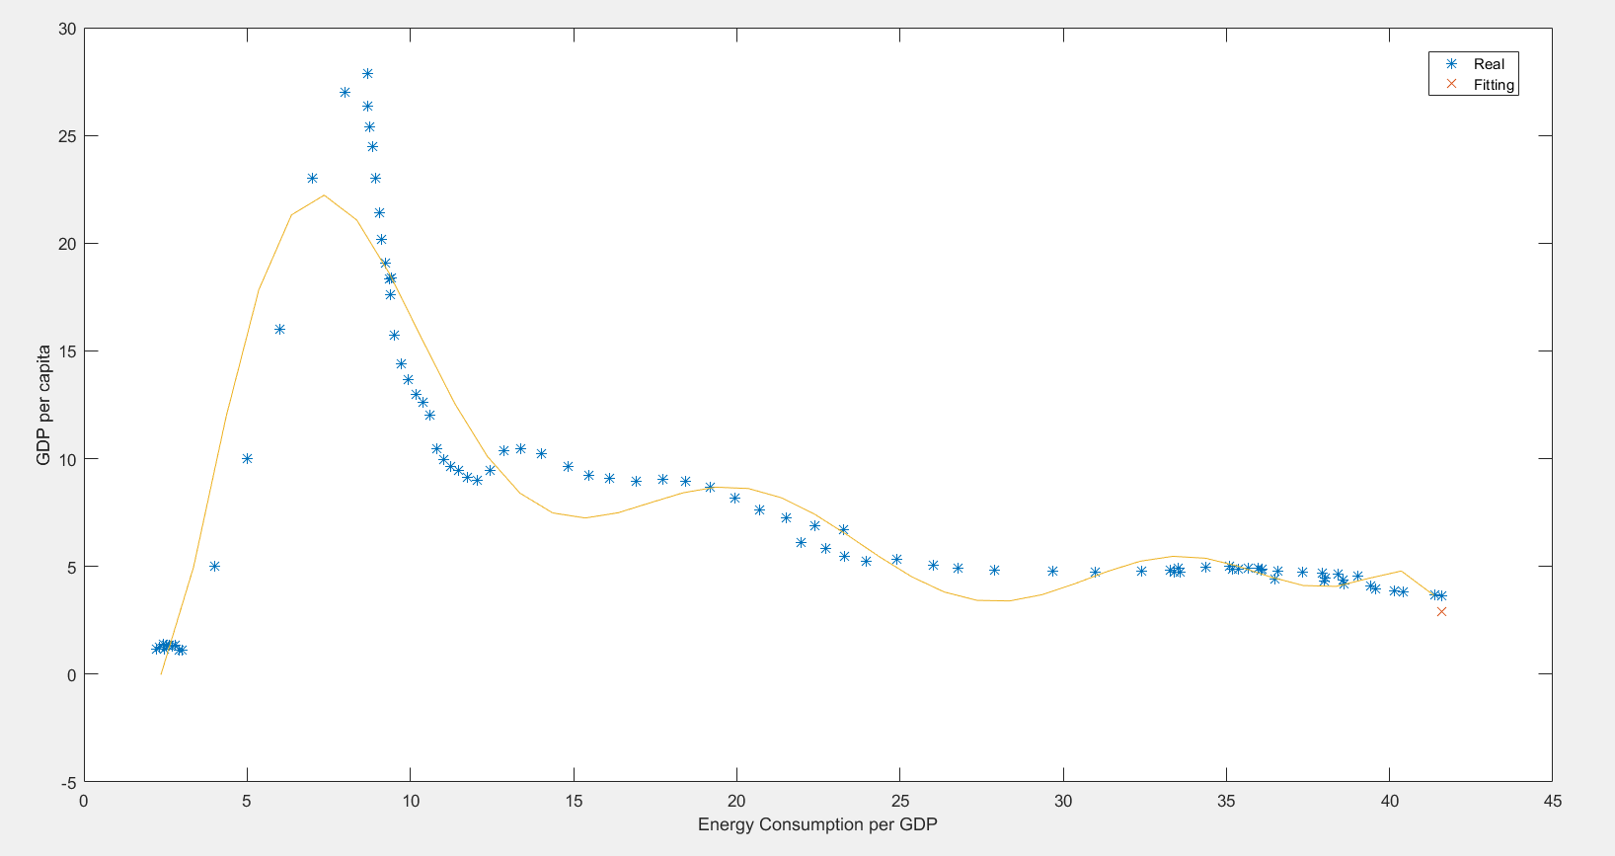

**7.1 Countries in the Early Stage of Industrialization**

The first type of country is in the early stage of industrialization, characterized by a high growth rate of per capita GDP and a high growth rate of per capita resource consumption. Representative countries are **Tanzania and Egypt**. For this kind of national economists and environmentalists, they have given accurate answers. In order to avoid falling into the Malthusian trap, on the one hand, it should be recommended that the country adopt a prenatal and postnatal care policy to cultivate more high-quality populations. It is not simply increasing the fertility rate, it is the heavy energy and environmental burden brought about by population expansion; on the other hand, the country should be provided with technical support and policy guidance to quickly transition from the early stage of industrialization to the late stage of industrialization, and give full play to the local characteristics of the industry Advantages instead of blindly emphasizing high output.

**7.2 Countries in the Middle of Industrialization**

The second type of country is in the middle of industrialization. It is characterized by a dense population, relatively developed local industries and a relatively complete industrial system. Representative countries are **China and Indonesia**. For this type of country, our recommendations are mainly to strengthen the adjustment of the industrial structure and energy structure. take China as an example. China has a large number of coal mines. In the past few decades, China's industry has formed an extremely high dependence on coal mines, which has also caused serious environmental problems. In order to avoid the deterioration of environmental and energy problems, the industrial structure should be promoted to shift from a resource-intensive industrial structure dominated by raw material industries and low value-added industries to a knowledge-intensive industry dominated by high value-added industries. Structural shift: In terms of energy structure, we should give priority to renewable energy and clean energy, such as nuclear energy, wind energy, and tidal energy. Take the following figure as an example. If we keep the growth rate of China's energy consumption unchanged and use our improved methods to adjust the energy structure, the total carbon emissions can be greatly reduced.

Figure14: The smart energy consumption plan of China

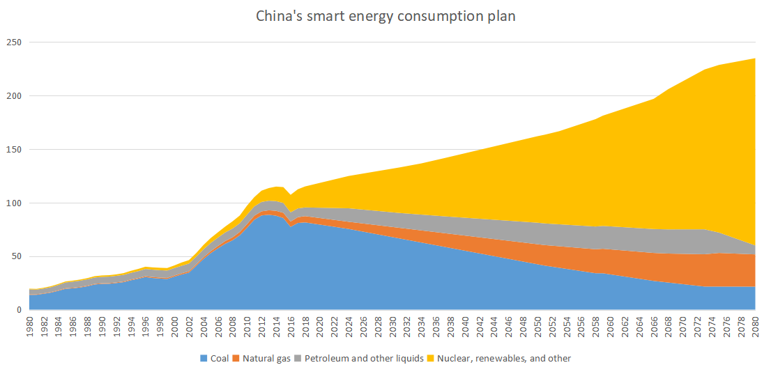

**7.3 Developed Countries**

The third type of countries are mostly developed countries, with high per capita GDP and low energy consumption per capita, but the per capita energy consumption is very high. Typical countries are **Sweden and the United States**. For this type of country, our recommendations are mainly to reduce per capita energy consumption and carbon emissions. Take France as an example. France has maintained a steady growth rate of energy consumption since the 1980s. In addition, France attaches great importance to nuclear energy, and France has greatly reduced carbon emissions while increasing its total energy consumption.

Figure15: The energy consumption of France

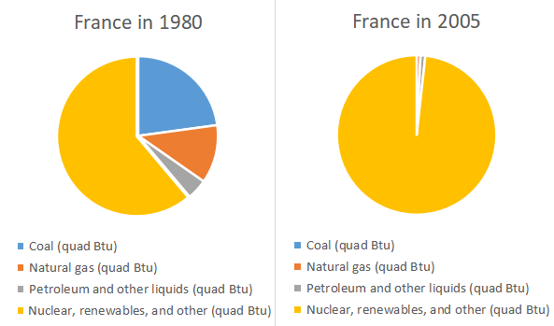

### 8. Model Analysis

#### 8.1 Advantages

① Data search is accurate and comprehensive. When forecasting oil price analysis combined with influencing factors, it can comprehensively analyze past historical data and determine indicators that more accurately assess the factors affecting oil prices. It can be more stable when making short-term oil price forecasts. , Accurate indicators;

②When considering the historical data of oil price factors, fully consider the singularity problem caused by the time point, accurately find the oil war that affects the fluctuation of oil price, first remove the oil value of these singularities that are difficult to estimate with a function, and make a function In the future, these singular points with large fluctuations will be separately analyzed and processed, and finally combined into the oil price prediction function;

③There is an accurate comparison of the results of the prediction model. After we study the factors through historical data and make a function, we use the function to predict the trend of oil prices in the next few years, and compare it with the oil price forecast fitted by the function to compare errors, Can better reflect the accuracy of the prediction model;

④ In the entire model, all the currency rates are taken into consideration, and all amounts are converted to the current currency rate for calculation, which improves the accuracy of the data and makes the model more accurate.

#### 8.2 Disadvantages

①When estimating oil prices, only short-term forecasts were made. Taking into account the uncertainty of policies and new energy development, no long-term forecasting models for oil prices were made;

②When dealing with historical oil price data and making reference forecasting models, the function fitting methods used are limited, making it difficult to make a comprehensive reference forecasting model, and to judge the accuracy of the oil price forecasting function we make through data;

③In the quantitative consideration of the factors of the oil price estimation model function, some specific cases are missing to illustrate, and some of the factors are too ideal, and some detailed considerations are ignored in the calculation;

④In Part I, when determining the parameters of oil production efficiency, the step-by-difference method is used to obtain the parameters of the Hubbert Curve. In a relatively short period of time, a segment of the Hubbert Curve can be regarded as a straight line, but the smallest segment of the time series is one year, which is somewhat inappropriate. The correct approach should be based on the parameters of Hubbert Curve as the independent variable, establish the likelihood ratio function, and use the "likelihood ratio function is **a unimodal function**" to solve it with the aid of **tri-division**.

#### 8.3 Sensitivity

Our model is based on the Hubbert Curve and focuses on the impact of the general law of the development of natural attributes of oil fields on the world oil production rate under the conditions of a market economy. However, as the world's greenhouse effect and global warming have intensified, more and more countries and organizations have begun to call for a reduction in the use of fossil energy. Many countries have introduced relevant policies to restrict the exploitation and use of oil. In the 1970s, OPEC used policy measures to restrict oil extraction, leading to a sharp rise in world oil prices.

It is easy to know that The total amount of oil that can be collected ultimately equals to the total amount collected before the oil runs out:

 (10)

Since the total amount of oil that can be collected ultimately are **constant**, if we adjust the government’s regulations on oil productivity caps, we can get this picture:

Figure 16: the influence of different rates on the oil depletion time

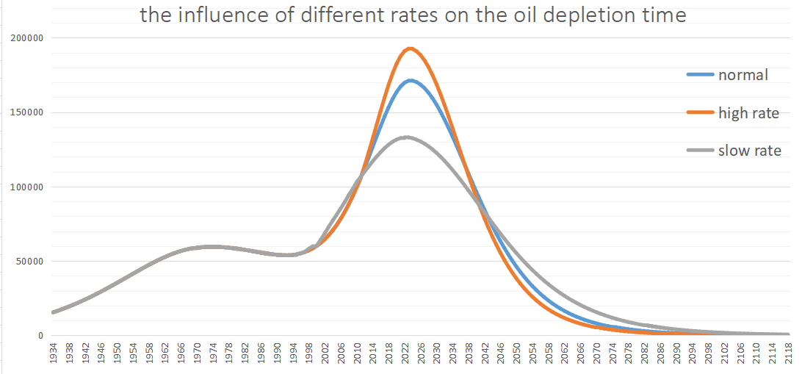

It can be found that **the past policies have effectively affected the next peak of oil extraction rate and delayed the depletion of oil**.

### A one-page letter to the UN

Based on our forecasts of future oil production trends and consumption trends and oil prices, we summarized our recommendations for energy utilization and wrote **a non-technical report** in accordance with the UN's energy plan.

**Ensure Access to Affordable, Reliable, Sustainable and Modern Energy for All**

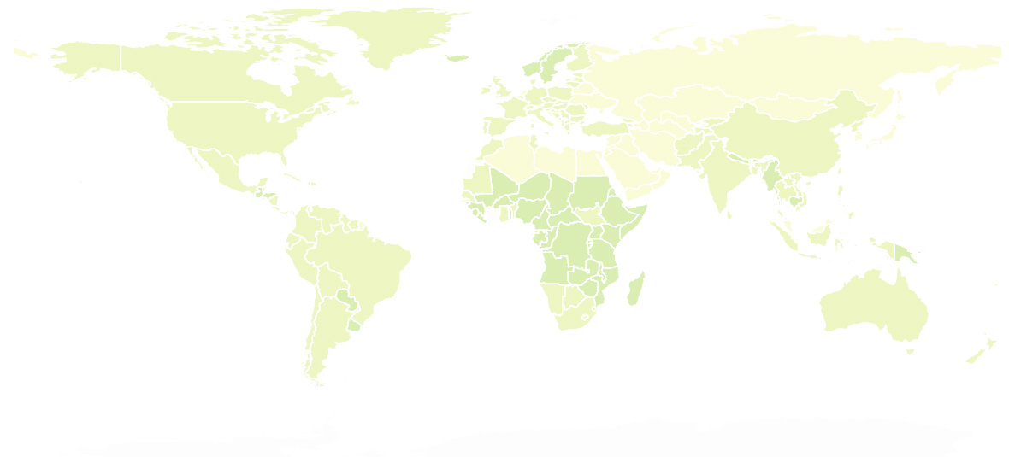The world is making progress towards Goal 7—”**Ensure access to affordable, reliable, sustainable and modern energy for all**” —with encouraging signs that energy is becoming more sustainable and widely available. Access to electricity in poorer countries has begun to accelerate, energy efficiency continues to improve, and renewable energy is making impressive gains in the electricity sector. However, measures should be continuously taken in terms of improving energy efficiency and increasing the proportion of renewable energy and clean energy.

**Provide policy, technical and economic support to economically backward countries**

Today, nearly 9 out of 10 people now have access to electricity, but reaching the unserved will require increased efforts. It is suggested to provide policy, technical and economic guidance for underdeveloped area, with local condition and energy sources taken into account.

In the process of industrialization in backward areas, special attention should be paid to the promotion and use of renewable energy. The international society need to take the responsibility for improve the energy structure of underdeveloped regions, in avoidance of the increasing of the use of the inefficient use of solid biomass, such as the burning of wood, charcoal or other organic matter.

**Improve energy efficiency by promoting technical exchanges**

The GDP of countries in the heyday of industrialization is very dependent on energy consumption. While economic development, these countries are also obliged to take the responsibility of improving the quality of development and protecting the global environment.

For this, on the one hand, energy efficiency must be improved. Improving energy efficiency—along with increasing energy access and affordability—is central to the global goal of reducing greenhouse gas emissions.In another hand, the government should progress in the electricity sector must extend to transportation and heating to meet an ambitious renewable energy target.

**Promote an environmentally friendly lifestyle in developed countries**

Developed countries have done a good job in the use and promotion of plot energy and renewable energy, which is due to the high social cost of high technology and pollution. However, from the perspective of per capita energy consumption, there is still room for improvement in developed countries. Take the United States as an example. The energy consumption per capita in the United States is ten times that of many developing countries. We need to promote an environmentally friendly lifestyle in developed countries.



Sincerely,

### Reference

* [1] Wu Binrong, Wang Lin, Lv Sheng-Xiang, Zeng Yu-Rong, Effective crude oil price forecasting using new text-based and big-data-driven model, Measurement, 2020.11
* [2] Lin Boqiang, Bai Rui, Oil prices and economic policy uncertainty: Evidence from global, oil importers, and exporters’ perspective, Research in International Business and Finance, 2020.12
* [3] [Jean Laherrère](https://en.wikipedia.org/wiki/Jean_Laherr%C3%A8re" \o "Jean Laherrère), [The Hubbert Curve: Its Strengths And Weaknesses](https://web.archive.org/web/20181009083419/http://www.dieoff.org/page191.htm) article by [Jean Laherrère](https://en.wikipedia.org/wiki/Jean_Laherr%C3%A8re" \o "Jean Laherrère). https://zh.wikipedia.org/w/index.php?search=The+Hubbert+Curve
* [4] Shaoul, Josef R. ,Ross, Michael J. ,Spitzer, Winston J. ,Wheaton, Stuart R. ,Mayland, Paul J. [Hydraulic Fracturing With Heated Fluids Brings Success in High-Pour-Point Waxy-Oil Reservoir in India](https://kns.cnki.net/KNS8/Detail/RedirectScholar?flag=TitleLink&tablename=SFJG_01&filename=SFJGACB341461D0A0FB6CD1E37D4E957439A" \t "https://kns.cnki.net/kns8/defaultresult/_blank), SPE Production & Operations, 2009.2
* [5] [Nanzad, B](http://apps.webofknowledge.com/OutboundService.do?SID=6BN5qjuAYIWJlDPMpWD&mode=rrcAuthorRecordService&action=go&product=WOS&lang=zh_CN&daisIds=19998301" \o "查找此作者的更多记录) (Nanzad, Bolorchimeg) ; [Anderson, KB](http://apps.webofknowledge.com/OutboundService.do?SID=6BN5qjuAYIWJlDPMpWD&mode=rrcAuthorRecordService&action=go&product=WOS&lang=zh_CN&daisIds=1933419" \o "查找此作者的更多记录) (Anderson, Ken B.)  [Conder, JA](http://apps.webofknowledge.com/OutboundService.do?SID=6BN5qjuAYIWJlDPMpWD&mode=rrcAuthorRecordService&action=go&product=WOS&lang=zh_CN&daisIds=1134599" \o "查找此作者的更多记录) (Conder, James A.) , Evaluation of the logit/probit transform method to modeling historical resource production and forecasting compared to conventional Hubbert modeling, INTERNATIONAL JOURNAL OF COAL GEOLOGY, 2017 , 42-51
* [6] [Sant'Ana, ID](http://apps.webofknowledge.com/OutboundService.do?SID=6BN5qjuAYIWJlDPMpWD&mode=rrcAuthorRecordService&action=go&product=WOS&lang=zh_CN&daisIds=16415747" \o "查找此作者的更多记录) (da Luz Sant'Ana, Istoni)(1);[Roman-Roman,P](http://apps.webofknowledge.com/OutboundService.do?SID=6BN5qjuAYIWJlDPMpWD&mode=rrcAuthorRecordService&action=go&product=WOS&lang=zh_CN&daisIds=1488326" \o "查找此作者的更多记录) (Roman-Roman, Patricia)(2); [Torres-Ruiz, F](http://apps.webofknowledge.com/OutboundService.do?SID=6BN5qjuAYIWJlDPMpWD&mode=rrcAuthorRecordService&action=go&product=WOS&lang=zh_CN&daisIds=1232155" \o "查找此作者的更多记录) (Torres-Ruiz, Francisco)([2](http://apps.webofknowledge.com/javascript:sup_focus('addressWOS:000434636000009-2'))), The Hubbert diffusion process: Estimation via simulated annealing and variable neighborhood search proceduresapplication to forecasting peak oil production, APPLIED STOCHASTIC MODELS IN BUSINESS AND INDUSTRY, 2018.5 , 376-394
* [7] Liang Qiang, Research on the Method and Application of Oil Price Forecast, 2008.5, CAS IR GRID, 40-60
* [8] Liu Ying, Research on the Periodicity of International Oil Price Fluctuation, 2010, Wanfang Data Knowledge Service Platform
* [9] Zhou Dequn, Sun Licheng , Wan Hong, Research on petroleum reserve model considering petroleum substitutes and tariff quota policy , Chinese Journal of Management Science, 2010.2, 146-157
* [10] Men Shulian, Study on New Energy Automobile Development under the Circumstances of Oil Shortage and Low-carbon Economy ,Measurement ,2011
* Ma Jia, Qin Ji-guang, Technology and Economy of Petroleum Substitutes, CHEMICAL TECHNO-ECONOMICS, 2006, 34-54

### Appendix

Polynomial fitting code

x=[1980,1981,1982,1983,1984,1985,1986,1987,1988,1989,1990,1991,1992,1993,1994,1995,1996,1997,1998,1999,2000,2001,2002,2003,2004,2005,2006,2007,2008,2009,2010,2011,2012,2013,2014,2015,2016,2017,2018,2019,2020];

y=[110,100,88,79,72,65,35,43,32,42,65,38,37,27,33,31,38,31,20,34,44,32,38,44,63,79,86,108,133,78,103,116,107,111,89,52,47,58,63,58,32];

x1=1980:2020;

x2=2020:2025;

[p2,s2]=polyfit(x,y,6);

y1=polyval(p2,x1);

y2=polyval(p2,x2);

plot(x,y,'*',x2,y2,'X',x1,y1);

legend('real','example')

xlabel('years')

ylabel('$')

Malthus：

x=[1980,1981,1982,1983,1984,1985,1986,1987,1988,1989,1990,1991,1992,1993,1994,1995,1996,1997,1998,1999,2000,2001,2002,2003,2004,2005,2006,2007,2008,2009,2010,2011,2012,2013,2014,2015,2016,2017,2018,2019,2020];

y=[110,100,88,79,72,65,35,43,32,42,65,38,37,27,33,31,38,31,20,34,44,32,38,44,63,79,86,108,133,78,103,116,107,111,89,52,47,58,63,58,32];

yy=log(y);

[p,s]=polyfit(x,yy,1);

[p2,s2]=polyfit(x,y,6);

xx=2020:2050;

yyy=exp(p(2)).*exp(p(1).*xx);

plot(x,y,'X',xx,yyy);

#include<bits/stdc++.h>

using namespace std;

typedef long long ll;

const int INF=0x3f3f3f3f;

int main(){

for(double i=-10;i<=10;i+=0.1)printf("%.1lf ",i);

return 0;

}

#include<bits/stdc++.h>

using namespace std;

typedef long long ll;

const int INF=0x3f3f3f3f;

double heat[5000],oil[5000];

const double e=2.718281828;

const double pi=3.1415926535;

double exp(double k){

return pow(e,k);

}

vector<double>X;

void Nor(double p=0,double d=1,int N=100){

default_random_engine E;

int cnt=0;

double y_lim1,y_lim2;

double x_lim=3*d;

y_lim1=(1/(d * (sqrt(2*pi)) ));

y_lim2=(1/(d * (sqrt(2*pi)) )) * exp(-(x_lim*x_lim) / (2*d*d));

//在3d外分类随机，提高效率

while(cnt<N){

uniform_int_distribution<unsigned>x_k(0,100);

if( x_k(E) <99){

uniform_real_distribution<double>xx(p-x_lim,p+x_lim);

double x=xx(E);

double y_up=(1/(d * (sqrt(2*pi)) )) * exp(-( (x-p) * (x-p) ) / (2*d*d));

uniform_real_distribution<double>y(0,y_lim1);

if(y(E)<=y_up){

X.push_back(x);

cnt++;

}

}else{

uniform_real_distribution<double>xx(p-100*d,p+100*d);

double x=xx(E);

double y_up=(1/(d * (sqrt(2*pi)) )) * exp(-( (x-p) * (x-p) ) / (2*d*d));

uniform_real_distribution<double>y(0,y_lim2);

if(y(E)<=y_up){

X.push_back(x);

cnt++;

}

}

}

}

int main(){

X.clear();

Nor(0,1e-5,100);

freopen("input1.txt","r",stdin);

freopen("output1.txt","w",stdout);

double sum1=0,sum2=0;

for(int i=1980;i<=2019;i++){

scanf("%lf",&heat[i]);

}

double k;

for(int i=1980;i<=1992;i++){

k=-(5e-6)*(i-1993)+(2e-3)+X[i-1980];

printf("%.2lf\n",heat[i]/k,k);

}

return 0;

}

%显示范围： d1=8/a 有效范围； d2=4/a;

a=1;

A=1;

x=-8/a:8/a/100:8/a;

t=exp(1).^(-x.*a);

y=A.*t./(1.+t).^2;

plot(x,y);

|  |  |  |  |
| --- | --- | --- | --- |
| 1980/1/1 | 108.78 | 106.89 | 32.5 |
| 1980/2/1 | 122.1 | 120.3 | 37 |
| 1980/3/1 | 123.54 | 117.62 | 38 |
| 1980/4/1 | 126.99 | 119.32 | 39.5 |
| 1980/5/1 | 125.73 | 123.45 | 39.5 |
| 1980/6/1 | 124.39 | 129.67 | 39.5 |
| 1980/7/1 | 124.39 | 115.45 | 39.5 |
| 1980/8/1 | 118.79 | 110.66 | 38 |
| 1980/9/1 | 111.6 | 103.56 | 36 |
| 1980/10/1 | 110.56 | 101.5 | 36 |
| 1980/11/1 | 109.62 | 120.56 | 36 |
| 1980/12/1 | 111.63 | 104.21 | 37 |
| 1981/1/1 | 113.73 | 121.05 | 38 |
| 1981/2/1 | 112.56 | 114.27 | 38 |
| 1981/3/1 | 111.8 | 105.32 | 38 |
| 1981/4/1 | 111.04 | 101.06 | 38 |
| 1981/5/1 | 110.2 | 110.58 | 38 |
| 1981/6/1 | 103.46 | 103.89 | 36 |
| 1981/7/1 | 102.35 | 90.56 | 36 |
| 1981/8/1 | 101.56 | 91.65 | 36 |
| 1981/9/1 | 100.58 | 115.68 | 36 |
| 1981/10/1 | 97.58 | 101.68 | 35 |
| 1981/11/1 | 100.04 | 108.31 | 36 |
| 1981/12/1 | 96.95 | 88.74 | 35 |
| 1982/1/1 | 93.46 | 101.63 | 33.85 |
| 1982/2/1 | 86.88 | 90.98 | 31.56 |
| 1982/3/1 | 78.46 | 71.65 | 28.48 |
| 1982/4/1 | 91.79 | 88.69 | 33.45 |
| 1982/5/1 | 97.66 | 87.85 | 35.93 |
| 1982/6/1 | 94.13 | 91.64 | 35.07 |
| 1982/7/1 | 91.24 | 89.77 | 34.16 |
| 1982/8/1 | 90.48 | 88.54 | 33.95 |
| 1982/9/1 | 94.78 | 93.31 | 35.63 |
| 1982/10/1 | 94.62 | 95.42 | 35.68 |
| 1982/11/1 | 90.74 | 90.22 | 34.15 |
| 1982/12/1 | 84.63 | 81.56 | 31.72 |
| 1983/1/1 | 83.03 | 80.54 | 31.19 |
| 1983/2/1 | 77.01 | 65.41 | 28.95 |
| 1983/3/1 | 77.91 | 70.58 | 29.29 |
| 1983/4/1 | 80.89 | 82.96 | 30.63 |
| 1983/5/1 | 79.41 | 74.63 | 30.25 |
| 1983/6/1 | 82.12 | 83.96 | 31.38 |
| 1983/7/1 | 83.39 | 85.79 | 32 |
| 1983/8/1 | 82.1 | 75.3 | 31.59 |
| 1983/9/1 | 78.51 | 61.25 | 30.36 |
| 1983/10/1 | 78.29 | 69.81 | 30.37 |
| 1983/11/1 | 75.21 | 70.35 | 29.23 |
| 1983/12/1 | 76.07 | 68.93 | 29.6 |
| 1984/1/1 | 76.6 | 70.42 | 29.98 |
| 1984/2/1 | 77.69 | 69.84 | 30.55 |
| 1984/3/1 | 78.3 | 71.82 | 30.85 |
| 1984/4/1 | 76.44 | 80.69 | 30.26 |
| 1984/5/1 | 77.63 | 74.55 | 30.83 |
| 1984/6/1 | 74.7 | 70.85 | 29.75 |
| 1984/7/1 | 69.03 | 64.56 | 27.6 |
| 1984/8/1 | 72.84 | 69.35 | 29.23 |
| 1984/9/1 | 73.56 | 70.68 | 29.66 |
| 1984/10/1 | 70.38 | 79.36 | 28.46 |
| 1984/11/1 | 67.54 | 79.55 | 27.31 |
| 1984/12/1 | 65.31 | 60.52 | 26.41 |
| 1985/1/1 | 65.18 | 68.91 | 26.41 |
| 1985/2/1 | 65.65 | 64.34 | 26.73 |
| 1985/3/1 | 69.23 | 58.36 | 28.29 |
| 1985/4/1 | 67.31 | 52.68 | 27.63 |
| 1985/5/1 | 67.57 | 61.5 | 27.84 |
| 1985/6/1 | 65.03 | 61.58 | 26.87 |
| 1985/7/1 | 65.49 | 68.22 | 27.12 |
| 1985/8/1 | 67.7 | 70.56 | 28.08 |
| 1985/9/1 | 69.91 | 78.56 | 29.08 |
| 1985/10/1 | 72.76 | 68.99 | 30.38 |
| 1985/11/1 | 71.07 | 75.41 | 29.75 |
| 1985/12/1 | 62.65 | 70.14 | 26.3 |
| 1986/1/1 | 44.74 | 51.8 | 18.83 |
| 1986/2/1 | 31.59 | 52.96 | 13.26 |
| 1986/3/1 | 24.94 | 30.58 | 10.42 |
| 1986/4/1 | 31.99 | 25.68 | 13.34 |
| 1986/5/1 | 34.19 | 35.63 | 14.3 |
| 1986/6/1 | 30.39 | 52.84 | 12.78 |
| 1986/7/1 | 26.51 | 21.58 | 11.15 |
| 1986/8/1 | 37.75 | 28.89 | 15.9 |
| 1986/9/1 | 34.9 | 29.68 | 14.77 |
| 1986/10/1 | 36.05 | 30.54 | 15.27 |
| 1986/11/1 | 35.39 | 28.69 | 15 |
| 1986/12/1 | 42.27 | 38.67 | 17.94 |
| 1987/1/1 | 43.91 | 48.59 | 18.75 |
| 1987/2/1 | 38.73 | 50.35 | 16.6 |
| 1987/3/1 | 43.74 | 40.2 | 18.83 |
| 1987/4/1 | 43.27 | 38.74 | 18.73 |
| 1987/5/1 | 44.61 | 34.52 | 19.38 |
| 1987/6/1 | 46.55 | 48.21 | 20.29 |
| 1987/7/1 | 48.89 | 44.55 | 21.37 |
| 1987/8/1 | 44.91 | 31.65 | 19.73 |
| 1987/9/1 | 44.35 | 32.58 | 19.59 |
| 1987/10/1 | 45.07 | 30.58 | 19.96 |
| 1987/11/1 | 41.76 | 32.54 | 18.51 |
| 1987/12/1 | 37.68 | 34.68 | 16.7 |
| 1988/1/1 | 38.13 | 32.58 | 16.94 |
| 1988/2/1 | 35.94 | 28.21 | 16.01 |
| 1988/3/1 | 38.17 | 31.21 | 17.08 |
| 1988/4/1 | 40.01 | 35.64 | 17.99 |
| 1988/5/1 | 38.8 | 29.21 | 17.51 |
| 1988/6/1 | 33.46 | 24.89 | 15.16 |
| 1988/7/1 | 35.83 | 40.93 | 16.31 |
| 1988/8/1 | 33.21 | 39.56 | 15.18 |
| 1988/9/1 | 29.07 | 36.42 | 13.37 |
| 1988/10/1 | 29.41 | 35.68 | 13.58 |
| 1988/11/1 | 33.15 | 30.24 | 15.32 |
| 1988/12/1 | 37.26 | 30.85 | 17.24 |
| 1989/1/1 | 36.61 | 38.63 | 17.03 |
| 1989/2/1 | 38.86 | 39.84 | 18.15 |
| 1989/3/1 | 42.98 | 58.61 | 20.19 |
| 1989/4/1 | 43.19 | 45.21 | 20.42 |
| 1989/5/1 | 41.85 | 40.08 | 19.9 |
| 1989/6/1 | 42.53 | 40.98 | 20.27 |
| 1989/7/1 | 38.32 | 28.01 | 18.31 |
| 1989/8/1 | 39.35 | 25.94 | 18.83 |
| 1989/9/1 | 41.93 | 30.62 | 20.13 |
| 1989/10/1 | 41.34 | 27.68 | 19.94 |
| 1989/11/1 | 41.13 | 32.55 | 19.89 |
| 1989/12/1 | 45.06 | 36.54 | 21.82 |
| 1990/1/1 | 46.36 | 64.52 | 22.68 |
| 1990/2/1 | 43.81 | 58.31 | 21.54 |
| 1990/3/1 | 41.03 | 40.87 | 20.28 |
| 1990/4/1 | 37.45 | 41.32 | 18.54 |
| 1990/5/1 | 35.06 | 24.96 | 17.4 |
| 1990/6/1 | 34.23 | 32.54 | 17.07 |
| 1990/7/1 | 41.32 | 38.66 | 20.69 |
| 1990/8/1 | 54.07 | 49.87 | 27.32 |
| 1990/9/1 | 77.52 | 82.5 | 39.51 |
| 1990/10/1 | 68.7 | 79.58 | 35.23 |
| 1990/11/1 | 56.14 | 61.23 | 28.85 |
| 1990/12/1 | 55.34 | 59.64 | 28.44 |
| 1991/1/1 | 41.68 | 58.98 | 21.54 |
| 1991/2/1 | 37.02 | 57.6 | 19.16 |
| 1991/3/1 | 37.87 | 31.52 | 19.63 |
| 1991/4/1 | 40.37 | 46.77 | 20.96 |
| 1991/5/1 | 40.57 | 48.91 | 21.13 |
| 1991/6/1 | 39.37 | 42.56 | 20.56 |
| 1991/7/1 | 41.45 | 38.69 | 21.68 |
| 1991/8/1 | 42.43 | 40.21 | 22.26 |
| 1991/9/1 | 42.19 | 39.1 | 22.23 |
| 1991/10/1 | 44.29 | 55.63 | 23.37 |
| 1991/11/1 | 40.6 | 52.15 | 21.48 |
| 1991/12/1 | 36.1 | 47.31 | 19.12 |
| 1992/1/1 | 35.65 | 41.28 | 18.9 |
| 1992/2/1 | 35.1 | 30.68 | 18.68 |
| 1992/3/1 | 36.33 | 24.65 | 19.44 |
| 1992/4/1 | 38.93 | 26.31 | 20.85 |
| 1992/5/1 | 41.21 | 29.31 | 22.11 |
| 1992/6/1 | 40.11 | 36.51 | 21.6 |
| 1992/7/1 | 40.53 | 35.92 | 21.87 |
| 1992/8/1 | 39.7 | 40.2 | 21.48 |
| 1992/9/1 | 40.01 | 40.85 | 21.71 |
| 1992/10/1 | 37.86 | 40.96 | 20.62 |
| 1992/11/1 | 36.48 | 38.63 | 19.89 |
| 1992/12/1 | 35.78 | 40.25 | 19.5 |
| 1993/1/1 | 36.99 | 38.59 | 20.26 |
| 1993/2/1 | 37.49 | 35.25 | 20.6 |
| 1993/3/1 | 37.06 | 34.88 | 20.44 |
| 1993/4/1 | 37.12 | 36.48 | 20.53 |
| 1993/5/1 | 36.16 | 37.42 | 20.02 |
| 1993/6/1 | 33.99 | 30.21 | 18.85 |
| 1993/7/1 | 32.24 | 30.58 | 17.88 |
| 1993/8/1 | 32.89 | 30.69 | 18.29 |
| 1993/9/1 | 33.73 | 31.2 | 18.79 |
| 1993/10/1 | 30.24 | 28.68 | 16.92 |
| 1993/11/1 | 27.56 | 24.97 | 15.43 |
| 1993/12/1 | 25.31 | 21.58 | 14.17 |
| 1994/1/1 | 27.05 | 18.63 | 15.19 |
| 1994/2/1 | 25.7 | 25.6 | 14.48 |
| 1994/3/1 | 26.16 | 24.3 | 14.79 |
| 1994/4/1 | 29.86 | 28.75 | 16.9 |
| 1994/5/1 | 32.32 | 30.66 | 18.31 |
| 1994/6/1 | 34.07 | 35.89 | 19.37 |
| 1994/7/1 | 35.63 | 36.91 | 20.3 |
| 1994/8/1 | 30.69 | 32.14 | 17.56 |
| 1994/9/1 | 32.05 | 31.09 | 18.39 |
| 1994/10/1 | 31.69 | 35.63 | 18.19 |
| 1994/11/1 | 31.39 | 37.84 | 18.05 |
| 1994/12/1 | 30.88 | 28.55 | 17.76 |
| 1995/1/1 | 31.85 | 27.16 | 18.39 |
| 1995/2/1 | 31.91 | 35.62 | 18.49 |
| 1995/3/1 | 32.97 | 31.51 | 19.17 |
| 1995/4/1 | 34.93 | 30.59 | 20.38 |
| 1995/5/1 | 32.32 | 32.65 | 18.89 |
| 1995/6/1 | 29.7 | 29.87 | 17.4 |
| 1995/7/1 | 29.97 | 30.26 | 17.56 |
| 1995/8/1 | 30.38 | 30.98 | 17.84 |
| 1995/9/1 | 29.82 | 30.47 | 17.54 |
| 1995/10/1 | 29.88 | 30.8 | 17.64 |
| 1995/11/1 | 30.82 | 30.53 | 18.18 |
| 1995/12/1 | 33.16 | 30.46 | 19.55 |
| 1996/1/1 | 29.91 | 30.59 | 17.74 |
| 1996/2/1 | 32.85 | 31.55 | 19.54 |
| 1996/3/1 | 35.9 | 30.21 | 21.47 |
| 1996/4/1 | 35.32 | 30.85 | 21.2 |
| 1996/5/1 | 32.86 | 30.98 | 19.76 |
| 1996/6/1 | 34.77 | 31.46 | 20.92 |
| 1996/7/1 | 33.88 | 29.84 | 20.42 |
| 1996/8/1 | 36.82 | 30.64 | 22.25 |
| 1996/9/1 | 40.23 | 38.21 | 24.38 |
| 1996/10/1 | 38.41 | 39.01 | 23.35 |
| 1996/11/1 | 39 | 38.46 | 23.75 |
| 1996/12/1 | 42.56 | 32.57 | 25.92 |
| 1997/1/1 | 39.53 | 30.64 | 24.15 |
| 1997/2/1 | 33.13 | 24.59 | 20.3 |
| 1997/3/1 | 33.21 | 39.65 | 20.41 |
| 1997/4/1 | 32.84 | 30.65 | 20.21 |
| 1997/5/1 | 33.95 | 30.48 | 20.88 |
| 1997/6/1 | 32.16 | 35.67 | 19.8 |
| 1997/7/1 | 32.67 | 34.97 | 20.14 |
| 1997/8/1 | 31.75 | 34.14 | 19.61 |
| 1997/9/1 | 34.21 | 35.88 | 21.18 |
| 1997/10/1 | 33.96 | 31.32 | 21.08 |
| 1997/11/1 | 30.87 | 27.58 | 19.15 |
| 1997/12/1 | 28.47 | 28.69 | 17.64 |
| 1998/1/1 | 27.73 | 30.65 | 17.21 |
| 1998/2/1 | 24.83 | 22.08 | 15.44 |
| 1998/3/1 | 25.05 | 26.41 | 15.61 |
| 1998/4/1 | 24.65 | 23.45 | 15.39 |
| 1998/5/1 | 24.3 | 22.58 | 15.2 |
| 1998/6/1 | 22.65 | 30.51 | 14.18 |
| 1998/7/1 | 22.68 | 29.84 | 14.21 |
| 1998/8/1 | 21.26 | 25.63 | 13.34 |
| 1998/9/1 | 25.69 | 22.45 | 16.14 |
| 1998/10/1 | 22.9 | 24.52 | 14.42 |
| 1998/11/1 | 17.82 | 19.67 | 11.22 |
| 1998/12/1 | 19.15 | 19.63 | 12.05 |
| 1999/1/1 | 20.21 | 19.98 | 12.75 |
| 1999/2/1 | 19.42 | 19.2 | 12.27 |
| 1999/3/1 | 26.45 | 25.87 | 16.76 |
| 1999/4/1 | 29.24 | 26.85 | 18.66 |
| 1999/5/1 | 26.39 | 25.63 | 16.84 |
| 1999/6/1 | 30.23 | 28.26 | 19.29 |
| 1999/7/1 | 32.07 | 31.65 | 20.53 |
| 1999/8/1 | 34.45 | 32.14 | 22.11 |
| 1999/9/1 | 38.02 | 40.11 | 24.51 |
| 1999/10/1 | 33.67 | 37.02 | 21.75 |
| 1999/11/1 | 38.04 | 36.85 | 24.59 |
| 1999/12/1 | 39.6 | 34.58 | 25.6 |
| 2000/1/1 | 42.65 | 40.24 | 27.64 |
| 2000/2/1 | 46.65 | 43.68 | 30.43 |
| 2000/3/1 | 40.91 | 41.56 | 26.9 |
| 2000/4/1 | 39.12 | 34.58 | 25.74 |
| 2000/5/1 | 44.04 | 41.56 | 29.01 |
| 2000/6/1 | 49.08 | 47.69 | 32.5 |
| 2000/7/1 | 41.34 | 40.56 | 27.43 |
| 2000/8/1 | 49.91 | 53.67 | 33.12 |
| 2000/9/1 | 46.23 | 50.2 | 30.84 |
| 2000/10/1 | 48.92 | 46.95 | 32.7 |
| 2000/11/1 | 50.59 | 49.63 | 33.82 |
| 2000/12/1 | 40.09 | 41.23 | 26.8 |
| 2001/1/1 | 42.62 | 40.08 | 28.66 |
| 2001/2/1 | 40.56 | 39.54 | 27.39 |
| 2001/3/1 | 38.86 | 34.67 | 26.29 |
| 2001/4/1 | 41.89 | 40.58 | 28.46 |
| 2001/5/1 | 41.56 | 43.63 | 28.37 |
| 2001/6/1 | 38.4 | 37.04 | 26.25 |
| 2001/7/1 | 38.66 | 38.44 | 26.35 |
| 2001/8/1 | 39.9 | 35.82 | 27.2 |
| 2001/9/1 | 34.21 | 36.97 | 23.43 |
| 2001/10/1 | 31.03 | 30.54 | 21.18 |
| 2001/11/1 | 28.54 | 29.41 | 19.44 |
| 2001/12/1 | 29.24 | 25.59 | 19.84 |
| 2002/1/1 | 28.64 | 26.62 | 19.48 |
| 2002/2/1 | 31.83 | 28.14 | 21.74 |
| 2002/3/1 | 38.31 | 34.58 | 26.31 |
| 2002/4/1 | 39.52 | 38.02 | 27.29 |
| 2002/5/1 | 36.65 | 38.66 | 25.31 |
| 2002/6/1 | 38.87 | 35.69 | 26.86 |
| 2002/7/1 | 39.07 | 34.87 | 27.02 |
| 2002/8/1 | 41.76 | 42.05 | 28.98 |
| 2002/9/1 | 43.82 | 46.53 | 30.45 |
| 2002/10/1 | 39.09 | 40.74 | 27.22 |
| 2002/11/1 | 38.61 | 38.21 | 26.89 |
| 2002/12/1 | 44.9 | 42.09 | 31.2 |
| 2003/1/1 | 48.02 | 50.68 | 33.51 |
| 2003/2/1 | 52.05 | 51.09 | 36.6 |
| 2003/3/1 | 43.89 | 53.64 | 31.04 |
| 2003/4/1 | 36.56 | 50.84 | 25.8 |
| 2003/5/1 | 41.95 | 56.89 | 29.56 |
| 2003/6/1 | 42.78 | 39.65 | 30.19 |
| 2003/7/1 | 43.24 | 40.51 | 30.54 |
| 2003/8/1 | 44.55 | 50.51 | 31.57 |
| 2003/9/1 | 41.06 | 48.74 | 29.2 |
| 2003/10/1 | 40.99 | 42.68 | 29.11 |
| 2003/11/1 | 42.91 | 43.58 | 30.41 |
| 2003/12/1 | 45.95 | 49.63 | 32.52 |
| 2004/1/1 | 46.47 | 50.65 | 33.05 |
| 2004/2/1 | 50.55 | 56.99 | 36.16 |
| 2004/3/1 | 49.67 | 52.2 | 35.76 |
| 2004/4/1 | 51.77 | 57.63 | 37.38 |
| 2004/5/1 | 54.91 | 54.05 | 39.88 |
| 2004/6/1 | 50.87 | 52.95 | 37.05 |
| 2004/7/1 | 60.23 | 56.14 | 43.8 |
| 2004/8/1 | 57.87 | 52.57 | 42.12 |
| 2004/9/1 | 68.06 | 53.85 | 49.64 |
| 2004/10/1 | 70.6 | 58.96 | 51.76 |
| 2004/11/1 | 66.96 | 57.12 | 49.13 |
| 2004/12/1 | 59.44 | 57.2 | 43.45 |
| 2005/1/1 | 65.79 | 75.68 | 48.2 |
| 2005/2/1 | 70.28 | 78.35 | 51.75 |
| 2005/3/1 | 74.62 | 80.38 | 55.4 |
| 2005/4/1 | 66.53 | 72.53 | 49.72 |
| 2005/5/1 | 69.59 | 75.24 | 51.97 |
| 2005/6/1 | 75.65 | 81.24 | 56.5 |
| 2005/7/1 | 80.74 | 89.65 | 60.57 |
| 2005/8/1 | 91.41 | 98.48 | 68.94 |
| 2005/9/1 | 86.77 | 84.68 | 66.24 |
| 2005/10/1 | 78.11 | 72.45 | 59.76 |
| 2005/11/1 | 75.55 | 78.93 | 57.32 |
| 2005/12/1 | 80.76 | 84.05 | 61.04 |
| 2006/1/1 | 89.18 | 92.07 | 67.92 |
| 2006/2/1 | 80.45 | 89.64 | 61.41 |
| 2006/3/1 | 86.82 | 91.05 | 66.63 |
| 2006/4/1 | 92.87 | 100.08 | 71.88 |
| 2006/5/1 | 91.68 | 98.45 | 71.29 |
| 2006/6/1 | 94.85 | 99.08 | 73.93 |
| 2006/7/1 | 95.23 | 102.51 | 74.4 |
| 2006/8/1 | 89.72 | 90.47 | 70.26 |
| 2006/9/1 | 80.71 | 79.56 | 62.91 |
| 2006/10/1 | 75.76 | 70.41 | 58.73 |
| 2006/11/1 | 81.56 | 70.23 | 63.13 |
| 2006/12/1 | 78.75 | 72.51 | 61.05 |
| 2007/1/1 | 74.77 | 86.03 | 58.14 |
| 2007/2/1 | 79.09 | 88.91 | 61.79 |
| 2007/3/1 | 83.52 | 83.01 | 65.87 |
| 2007/4/1 | 82.79 | 82.68 | 65.71 |
| 2007/5/1 | 80.14 | 80.41 | 64.01 |
| 2007/6/1 | 88.35 | 87.62 | 70.68 |
| 2007/7/1 | 97.76 | 89.68 | 78.21 |
| 2007/8/1 | 92.7 | 91.85 | 74.04 |
| 2007/9/1 | 101.99 | 104.85 | 81.66 |
| 2007/10/1 | 117.78 | 121.94 | 94.53 |
| 2007/11/1 | 109.91 | 130.54 | 88.71 |
| 2007/12/1 | 119.02 | 129.84 | 95.98 |
| 2008/1/1 | 113.22 | 127.63 | 91.75 |
| 2008/2/1 | 125.26 | 123.39 | 101.84 |
| 2008/3/1 | 123.83 | 120.67 | 101.58 |
| 2008/4/1 | 137.51 | 113.46 | 113.46 |
| 2008/5/1 | 153.07 | 127.35 | 127.35 |
| 2008/6/1 | 166.6 | 140 | 140 |
| 2008/7/1 | 146.91 | 124.08 | 124.08 |
| 2008/8/1 | 137.28 | 115.46 | 115.46 |
| 2008/9/1 | 119.76 | 100.64 | 100.64 |
| 2008/10/1 | 81.51 | 67.81 | 67.81 |
| 2008/11/1 | 66.73 | 54.43 | 54.43 |
| 2008/12/1 | 55.26 | 44.6 | 44.6 |
| 2009/1/1 | 51.39 | 41.68 | 41.68 |
| 2009/2/1 | 54.92 | 44.76 | 44.76 |
| 2009/3/1 | 60.78 | 49.66 | 49.66 |
| 2009/4/1 | 62.42 | 51.12 | 51.12 |
| 2009/5/1 | 80.77 | 66.31 | 66.31 |
| 2009/6/1 | 84.36 | 69.89 | 69.89 |
| 2009/7/1 | 83.97 | 69.45 | 69.45 |
| 2009/8/1 | 84.37 | 69.96 | 69.96 |
| 2009/9/1 | 85.16 | 70.61 | 70.61 |
| 2009/10/1 | 92.79 | 77 | 77 |
| 2009/11/1 | 93.05 | 77.28 | 77.28 |
| 2009/12/1 | 95.71 | 79.36 | 79.36 |
| 2010/1/1 | 87.61 | 72.89 | 72.89 |
| 2010/2/1 | 95.67 | 79.66 | 79.66 |
| 2010/3/1 | 100.18 | 83.76 | 83.76 |
| 2010/4/1 | 102.86 | 96.54 | 86.15 |
| 2010/5/1 | 88.25 | 101.65 | 73.97 |
| 2010/6/1 | 90.38 | 82.1 | 75.63 |
| 2010/7/1 | 94.27 | 78.95 | 78.95 |
| 2010/8/1 | 85.8 | 71.92 | 71.92 |
| 2010/9/1 | 95.32 | 79.97 | 79.97 |
| 2010/10/1 | 96.98 | 81.43 | 81.43 |
| 2010/11/1 | 100.09 | 90.6 | 84.11 |
| 2010/12/1 | 108.56 | 92.51 | 91.38 |
| 2011/1/1 | 108.97 | 95.28 | 92.19 |
| 2011/2/1 | 114.13 | 105.68 | 96.97 |
| 2011/3/1 | 124.33 | 117.92 | 106.72 |
| 2011/4/1 | 131.93 | 124.65 | 113.93 |
| 2011/5/1 | 118.31 | 112.07 | 102.7 |
| 2011/6/1 | 110.11 | 98.56 | 95.42 |
| 2011/7/1 | 110.34 | 95.7 | 95.7 |
| 2011/8/1 | 102.04 | 88.81 | 88.81 |
| 2011/9/1 | 90.92 | 85.63 | 79.2 |
| 2011/10/1 | 107.17 | 98.24 | 93.19 |
| 2011/11/1 | 115.51 | 100.36 | 100.36 |
| 2011/12/1 | 114.05 | 108.85 | 98.83 |
| 2012/1/1 | 113.15 | 105.64 | 98.48 |
| 2012/2/1 | 122.49 | 114.2 | 107.07 |
| 2012/3/1 | 116.93 | 109.86 | 103.02 |
| 2012/4/1 | 118.71 | 107.23 | 104.87 |
| 2012/5/1 | 98.04 | 104.25 | 86.53 |
| 2012/6/1 | 96.43 | 95.31 | 84.96 |
| 2012/7/1 | 100.12 | 91.04 | 88.06 |
| 2012/8/1 | 109.01 | 95.32 | 96.47 |
| 2012/9/1 | 103.71 | 108.69 | 92.19 |
| 2012/10/1 | 97.11 | 107.52 | 86.24 |
| 2012/11/1 | 100.56 | 106.99 | 88.91 |
| 2012/12/1 | 104.12 | 105.41 | 91.82 |
| 2013/1/1 | 110.26 | 112.65 | 97.49 |
| 2013/2/1 | 103.28 | 115.87 | 92.05 |
| 2013/3/1 | 108.8 | 119.25 | 97.23 |
| 2013/4/1 | 104.68 | 118.64 | 93.46 |
| 2013/5/1 | 102.82 | 114.27 | 91.97 |
| 2013/6/1 | 107.66 | 101.36 | 96.56 |
| 2013/7/1 | 117.11 | 104.52 | 105.03 |
| 2013/8/1 | 119.81 | 103.64 | 107.65 |
| 2013/9/1 | 113.79 | 102.85 | 102.33 |
| 2013/10/1 | 107.46 | 103.68 | 96.38 |
| 2013/11/1 | 103.57 | 102.96 | 92.72 |
| 2013/12/1 | 109.94 | 101.58 | 98.42 |
| 2014/1/1 | 108.51 | 100.74 | 97.49 |
| 2014/2/1 | 113.77 | 102.88 | 102.59 |
| 2014/3/1 | 111.94 | 101.58 | 101.58 |
| 2014/4/1 | 109.51 | 104.68 | 99.74 |
| 2014/5/1 | 112.47 | 105.74 | 102.71 |
| 2014/6/1 | 115.06 | 108.63 | 105.37 |
| 2014/7/1 | 107.3 | 107.92 | 98.17 |
| 2014/8/1 | 105.08 | 101.25 | 95.96 |
| 2014/9/1 | 99.73 | 100.57 | 91.16 |
| 2014/10/1 | 88.35 | 91.65 | 80.54 |
| 2014/11/1 | 72.96 | 88.34 | 66.15 |
| 2014/12/1 | 59.08 | 87.54 | 53.27 |
| 2015/1/1 | 53.74 | 47.26 | 48.24 |
| 2015/2/1 | 55.18 | 46.92 | 49.76 |
| 2015/3/1 | 52.5 | 42.2 | 47.6 |
| 2015/4/1 | 65.65 | 43.86 | 59.63 |
| 2015/5/1 | 66.03 | 50.9 | 60.3 |
| 2015/6/1 | 64.88 | 51.47 | 59.47 |
| 2015/7/1 | 51.41 | 56.82 | 47.12 |
| 2015/8/1 | 53.78 | 58.61 | 49.2 |
| 2015/9/1 | 49.33 | 57.93 | 45.09 |
| 2015/10/1 | 51.02 | 58.64 | 46.59 |
| 2015/11/1 | 45.69 | 52.77 | 41.65 |
| 2015/12/1 | 40.78 | 50.33 | 37.04 |
| 2016/1/1 | 36.95 | 38.74 | 33.62 |
| 2016/2/1 | 37.06 | 36.95 | 33.75 |
| 2016/3/1 | 41.91 | 32.84 | 38.34 |
| 2016/4/1 | 49.96 | 39.68 | 45.92 |
| 2016/5/1 | 53.22 | 44.76 | 49.1 |
| 2016/6/1 | 52.2 | 45.68 | 48.33 |
| 2016/7/1 | 45.01 | 45.26 | 41.6 |
| 2016/8/1 | 48.32 | 47.58 | 44.7 |
| 2016/9/1 | 52.05 | 49.62 | 48.24 |
| 2016/10/1 | 50.47 | 52.04 | 46.86 |
| 2016/11/1 | 53.35 | 50.68 | 49.44 |
| 2016/12/1 | 57.96 | 54.68 | 53.72 |
| 2017/1/1 | 56.61 | 58.95 | 52.81 |
| 2017/2/1 | 57.74 | 58.53 | 54.01 |
| 2017/3/1 | 54.04 | 55.85 | 50.6 |
| 2017/4/1 | 52.54 | 56.78 | 49.33 |
| 2017/5/1 | 51.41 | 54.9 | 48.32 |
| 2017/6/1 | 48.94 | 50.47 | 46.04 |
| 2017/7/1 | 53.38 | 58.21 | 50.17 |
| 2017/8/1 | 50.11 | 52.68 | 47.23 |
| 2017/9/1 | 54.51 | 50.44 | 51.67 |
| 2017/10/1 | 57.43 | 52.89 | 54.38 |
| 2017/11/1 | 60.61 | 54.88 | 57.4 |
| 2017/12/1 | 63.8 | 58.95 | 60.42 |
| 2018/1/1 | 68.03 | 64.72 | 64.73 |
| 2018/2/1 | 64.48 | 60.82 | 61.64 |
| 2018/3/1 | 67.73 | 64.35 | 64.94 |
| 2018/4/1 | 71.24 | 68.95 | 68.57 |
| 2018/5/1 | 69.39 | 68.71 | 67.04 |
| 2018/6/1 | 76.6 | 68.88 | 74.15 |
| 2018/7/1 | 71.03 | 73.52 | 68.76 |
| 2018/8/1 | 72.1 | 72.65 | 69.8 |
| 2018/9/1 | 75.52 | 75.1 | 73.25 |
| 2018/10/1 | 67.27 | 71.28 | 65.31 |
| 2018/11/1 | 52.61 | 58.96 | 50.93 |
| 2018/12/1 | 47.04 | 50.57 | 45.41 |
| 2019/1/1 | 55.62 | 52.35 | 53.79 |
| 2019/2/1 | 58.94 | 58.63 | 57.22 |
| 2019/3/1 | 61.58 | 60.24 | 60.14 |
| 2019/4/1 | 65.12 | 63.99 | 63.91 |
| 2019/5/1 | 54.41 | 58.64 | 53.5 |
| 2019/6/1 | 59.46 | 59.74 | 58.47 |
| 2019/7/1 | 59.46 | 54.12 | 58.58 |
| 2019/8/1 | 55.93 | 54.76 | 55.1 |
| 2019/9/1 | 54.83 | 54.17 | 54.07 |
| 2019/10/1 | 54.83 | 52.14 | 54.18 |
| 2019/11/1 | 55.83 | 53.68 | 55.17 |
| 2019/12/1 | 61.85 | 58.96 | 61.06 |
| 2020/1/1 | 52.02 | 52.87 | 51.56 |
| 2020/2/1 | 45.07 | 47.68 | 44.76 |
| 2020/3/1 | 20.66 | 41.25 | 20.48 |
| 2020/4/1 | 19.14 | 38.68 | 18.84 |
| 2020/5/1 | 36.06 | 39.84 | 35.49 |
| 2020/6/1 | 39.66 | 40.25 | 39.27 |
| 2020/7/1 | 40.47 | 43.68 | 40.27 |
| 2020/8/1 | 42.7 | 41.49 | 42.61 |
| 2020/9/1 | 40.22 | 43.51 | 40.22 |
| 2020/10/1 | 35.79 | 38.72 | 35.79 |
| 2020/11/1 | 45.34 | 46.94 | 45.34 |
| 2020/12/1 | 44.55 | 45.87 | 44.55 |